EXCUSE LETTER

September 9 2022

To Mr. Jefferson P. Torres

I, Rei Benedict L. Millano of grade 12 Laplace. One of the students of your advisory Class, was absent on September 8 2022 due to a mild fever. But now I am feeling much better and I’m confident to fully be present on next week’s face to face classes.

This letter is signed by my mother; Geraldine L. Millano.

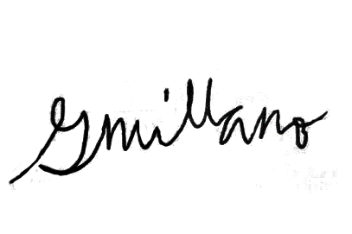

Parent’s Signature